**Wall design**

**Wall design 1:**

Restaurant Decorative partition metal screen /Room wall divider

Price : Rs. 2500/piece

**Quick Details**

Type:

Screens & Room Dividers

Style:

Traditional Chinese, Modern and Simple

Fans:

4

Leaf Quantity:

3

Technics:

COATING

Theme:

Construction

Function:

Multi-Functional, Balacony and floor

Conformation:

Frame Structure

Place of Origin:

Guangdong, China

Brand Name:

Sanseng

Model Number:

SC-362

Material:

Metal

Metal Type:

Stainless Steel

Product Name:

Hotel Restaurant Decorative partition metal screen /Room wall divider

Color:

Satin/Polished

Size:

Standard or Customized

Usage:

Stairs/Handrail

Package:

Carton

Certificate:

ISO

Installation:

Easy Diy Install

Application:

Staircase

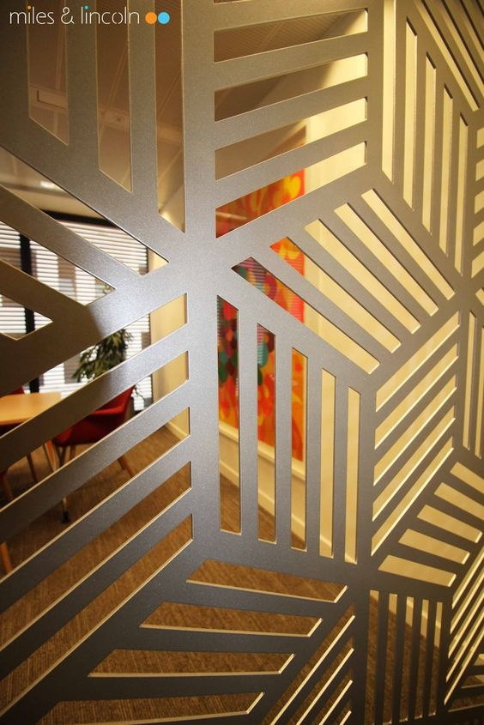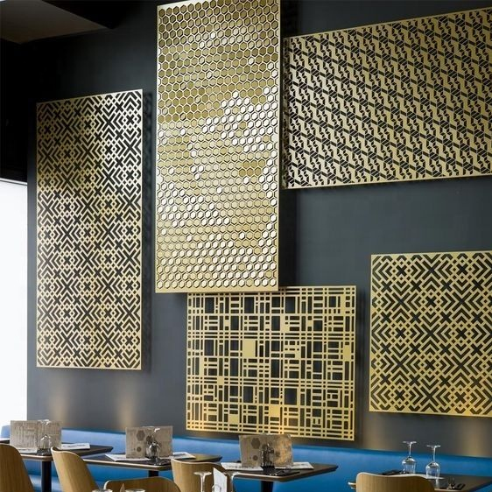



**Wall design 2:**

# **Indian use background wall design for restaurant modern decoration wallcoverings wallpaper**

**Price: 225/roll**

**Quick Details**

Type:

Wall Coating

Place of Origin:

Beijing, China

Brand Name:

MSYD

Model Number:

oyana

Function:

Anti-static, Fireproof, Heat Insulation, Moisture-Proof, Mould-Proof, Smoke-Proof, Sound-Absorbing, Soundproof, Waterproof

Usage:

Administration, Commerce, Entertainment, Household

Style:

Country

Thickness:

380g/sqm

Certification:

CE, SGS, ISO9001, ISO14001

Ink type:

water ink

Color:

for options

Roll weight:

1.2kg

Width:

0.53m

Length:

10m

Packaging:

per carton boxs

Material:

pvc wallpaper

Design:

for options

